Installation and Configuration of virtualization using KVM.

COMMANDS FOR KVM INSTALLATION & VM SETUP

System Update
sudo pacman -Syu

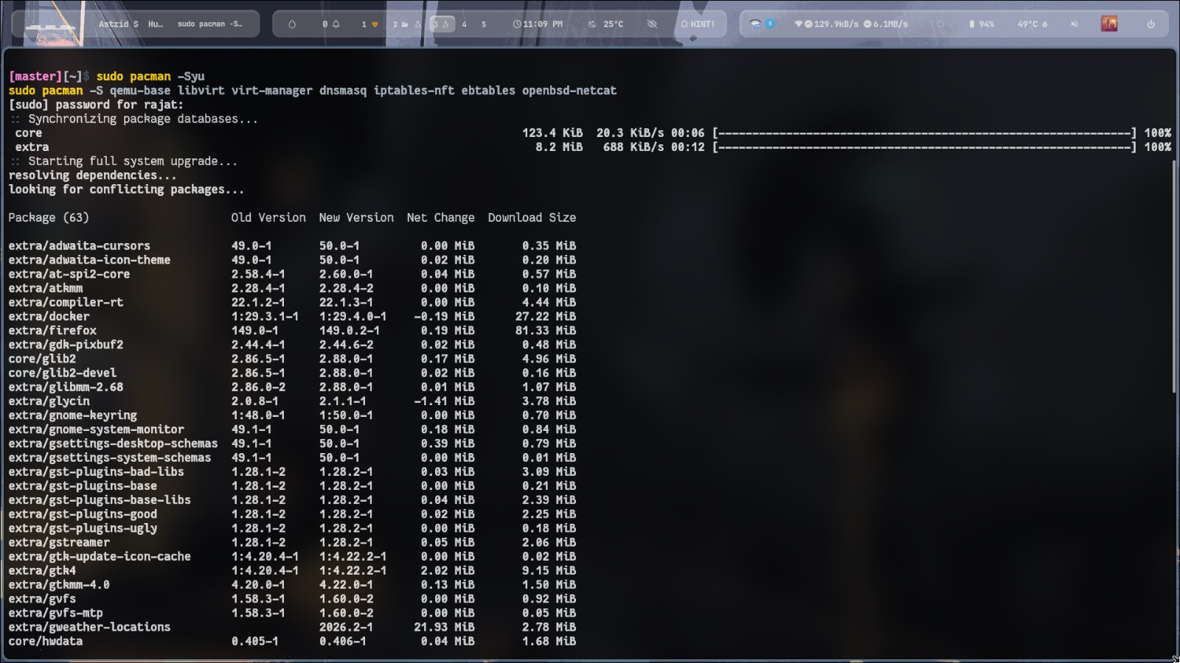

2. Install Required Packages
sudo pacman -S qemu-base libvirt virt-manager dnsmasq iptables-nft ebtables openbsd-netcat

3. Enable libvirt Service
sudo systemctl enable libvirtd --now
systemctl status libvirtd

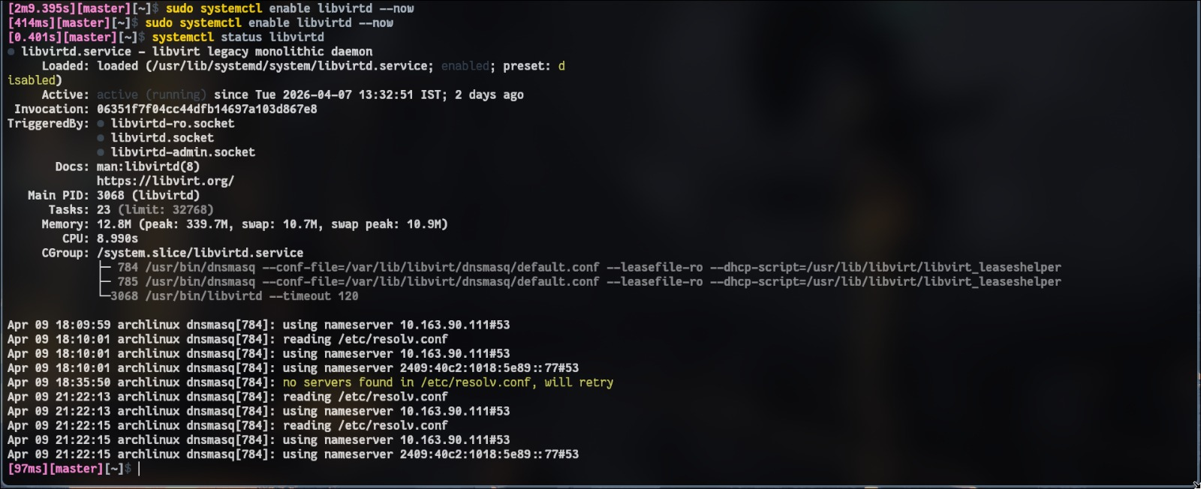

4. Add User to Required Groups
sudo usermod -aG libvirt $(whoami)
sudo usermod -aG kvm $(whoami)

5. Install Kernel & Headers
sudo pacman -S linux linux-headers
sudo reboot

6. Check Bridge Module
lsmod | grep bridge
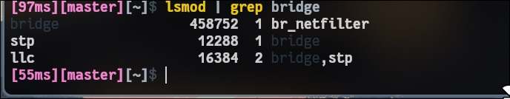

7.Create Default Network
sudo nano /etc/libvirt/qemu/networks/default.xml
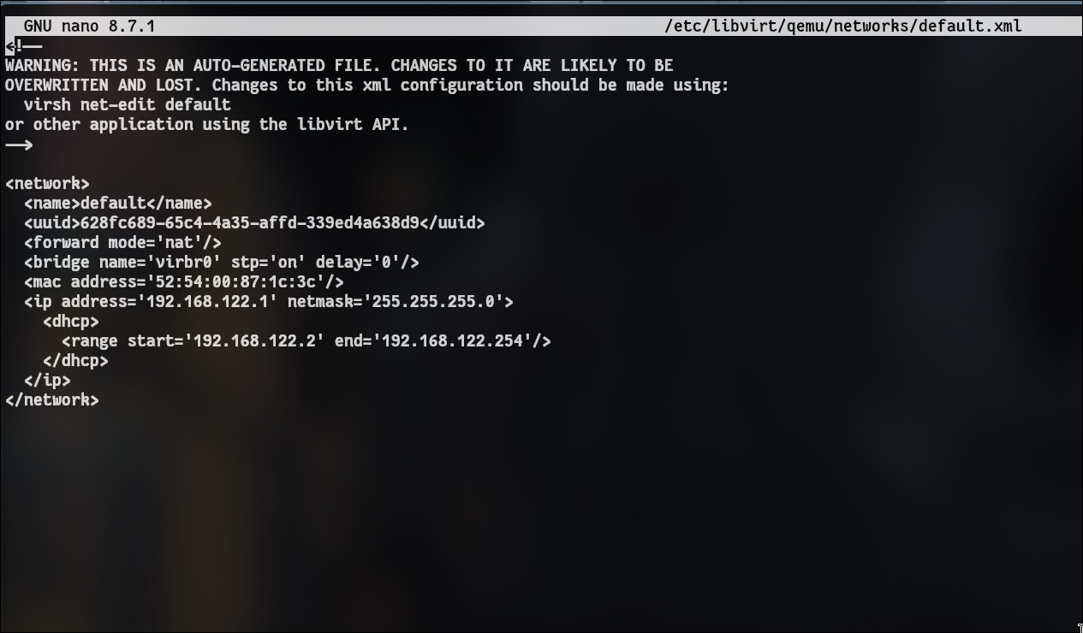
<network>
<name>default</name>
<forward mode='nat'/>
<bridge name='virbr0' stp='on' delay='0'/>
<ip address='192.168.122.1' netmask='255.255.255.0'>
<dhcp>
<range start='192.168.122.2' end='192.168.122.254'/>
</dhcp>
</ip>
</network>

8.Define, Start & Enable Network
sudo virsh net-define /etc/libvirt/qemu/networks/default.xml
sudo virsh net-start default
sudo virsh net-autostart default

9. Verify Network
ip a | grep virbr0

10.Launch Virtual Machine Manager
virt-manager

VM CREATION STEPS (INSIDE VIRTUAL MACHINE MANAGER)

Step 1: Start VM Creation
- Click "Create a new virtual machine"

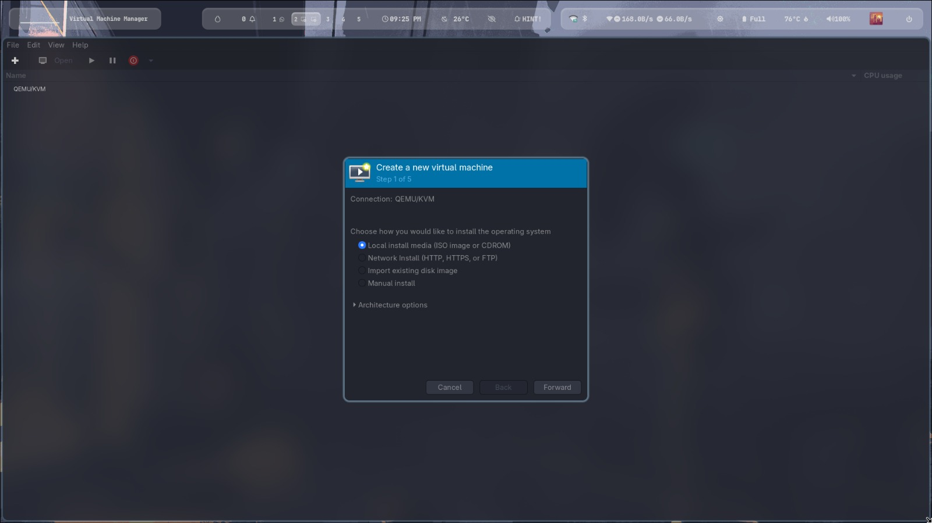

Step 2: Choose Installation Method
- Select: Local install media (ISO image or CDROM)
- Click Forward
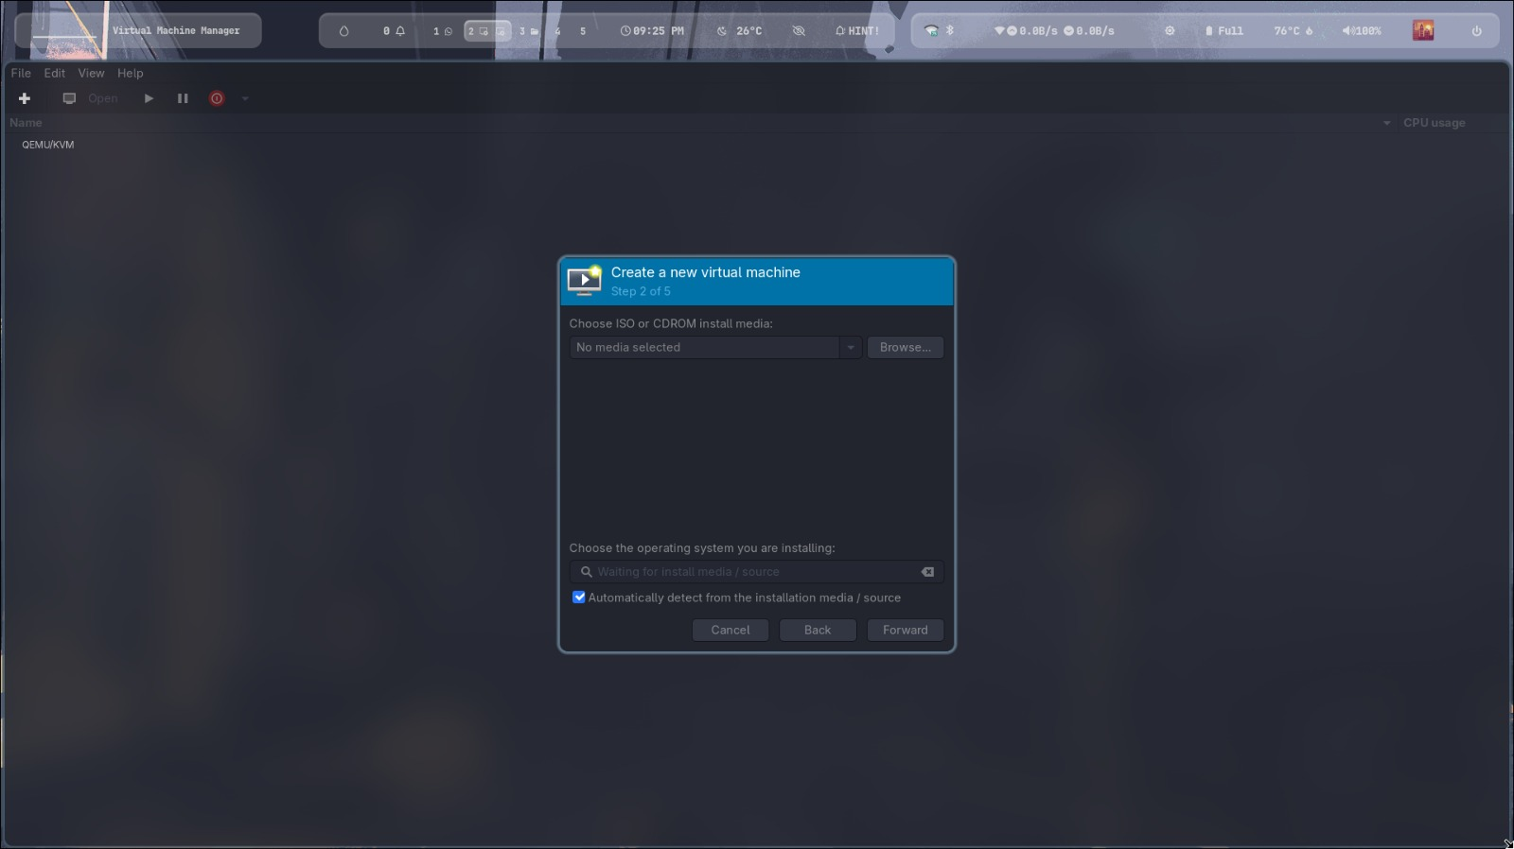

Step 3: Select ISO File
- Click Browse → Browse Local
- Select your OS ISO file (e.g., Ubuntu ISO)
- Click Forward
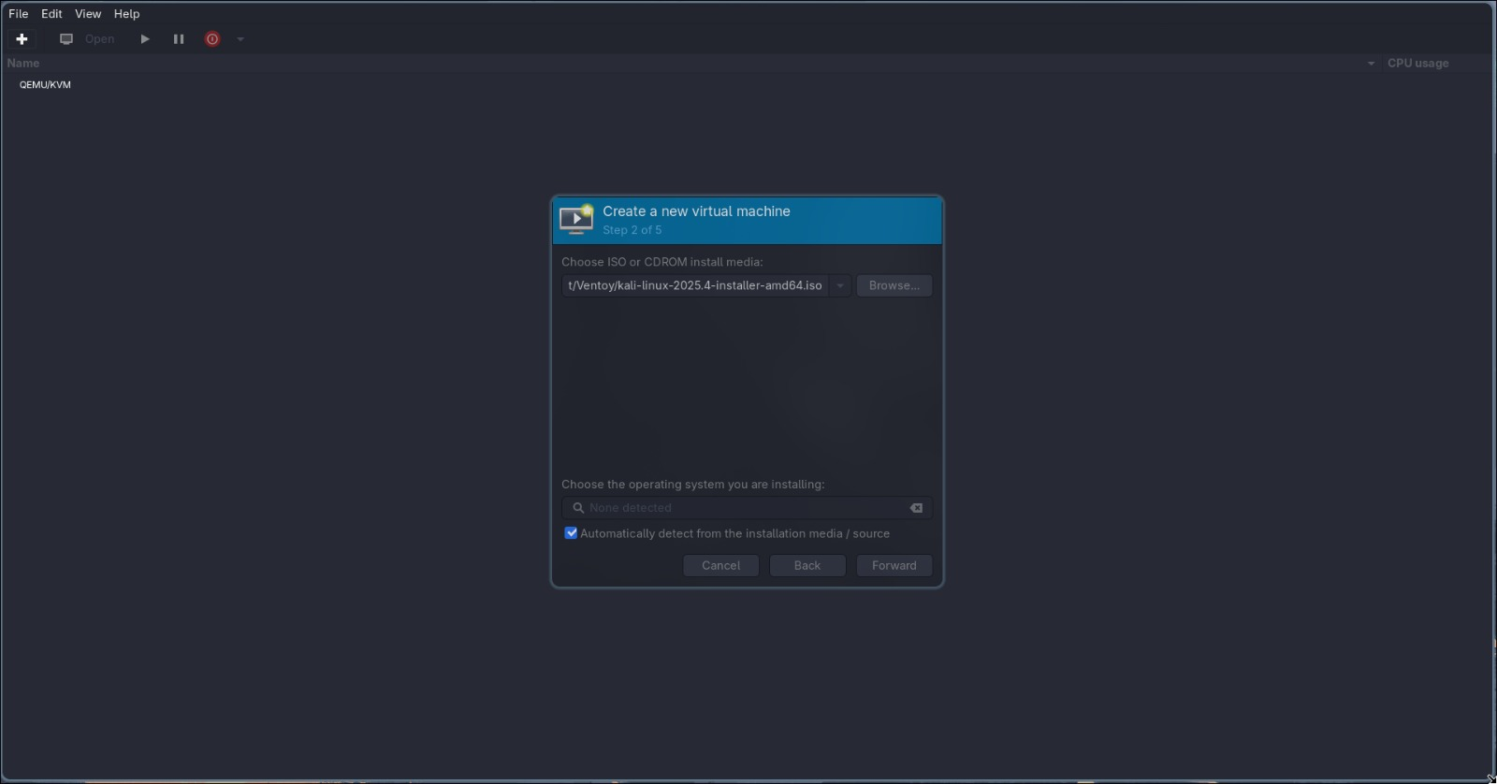

Step 4: Set Memory & CPU
- RAM: 2048 MB (2 GB)
- CPU: 2 cores
- Click Forward
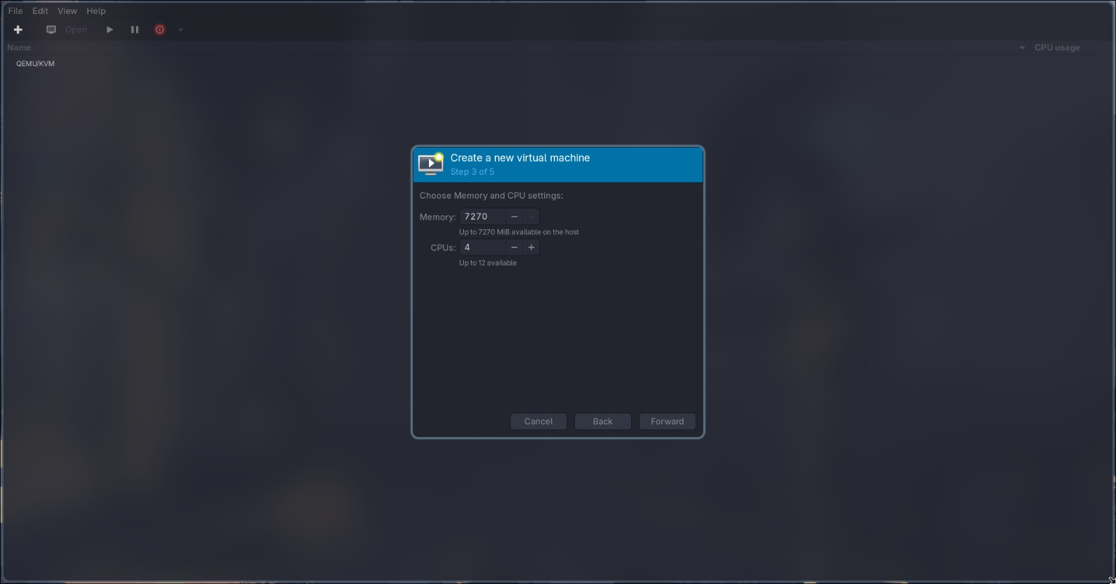

Step 5: Create Disk
- Select: Create a disk image
- Size: 20 GB
- Click Forward
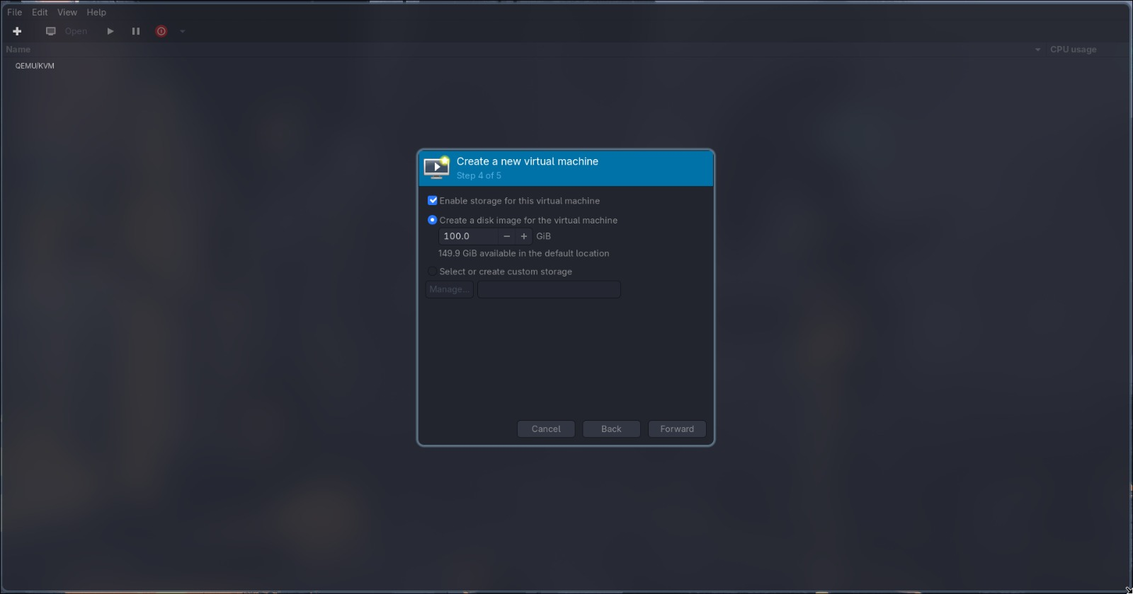

Step 6: Final Configuration
- Name your VM (e.g., Ubuntu-VM)
- Ensure network is NAT (default)
- Click Finish
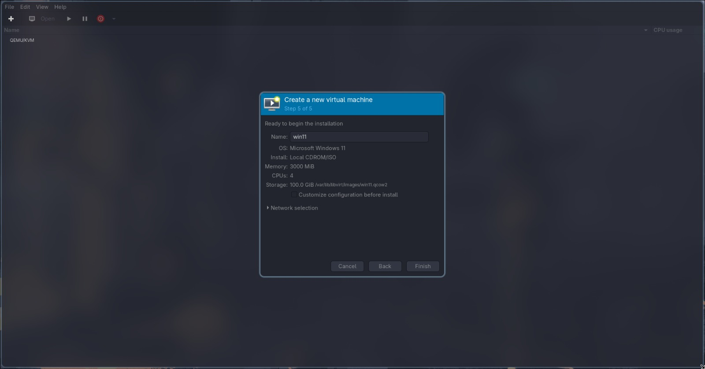

Step 7: Start Installation
- VM will automatically start
- OS installer screen will appear

Step 8: Install OS
- Follow on-screen instructions (language, user, password, etc.)

